“DEVELOP PYTHON CODE FOR YIELD PREDICTION”

By
Kaneriya Parth
Kalola Deep
Jivani Parth
Moliya Vatsal

Junagadh Agricultural University



Dhirubhai Ambani Institute of Information and Communication Technology

Date:19/7/2019
- MOTIVATION:
India is growing fast in population. The demand is high and will increase in coming future. By area about 75 million ha is rainfed and totally depends on rains facing the vagaries of monsoon. For this a combined structural and methodological approach like variety inception, pesticide & fertilizer management, integrated cropping, rainwater harvesting, efficient irrigation techniques etc. would be required. Also, it becomes essential to simulate & predict the crop yield under ambient conditions prior to the implementation stage for effective crop management & desired results, more so in the rainfed area and when India is trending towards precision farming practices. Yield prediction is a very important in agriculture sector for the farmers, prediction will help to overcome situation like drought, rainfall etc.

2. OBJECTIVE:
We have dataset of different weather parameters of past 27 years and meteorological week 44-52 to next year meteorological week 1-11(Rabi season). By using this dataset we want to build a multiple linear regression model which can predict crop yield.

3. DATA USED:
We have data of 7 weather parameters (Weekly average of Rabi season) and yield of wheat of Anand district.
Weather parameters used: Bright sunshine hours (BSS), Maximum Temperature (Tmax), Minimum Temperature (Tmin), Relative Humidity (Rh1,Rh2), Vapour Pressure(Vp1,Vp2).

4. APPROACH / METHODOLOGY:
We find 56 features by statistical approach, which can be used in model. After finding correlation of 56 features with yield, we used top correlated features in multiple linear regression to build yield prediction model. By, Multiple linear regression we find coefficient and intercept of equation which can predict crop yield. With help of equation we passed current weather parameter and we predicted crop yield.

Equation used:
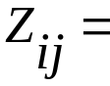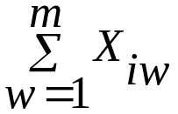
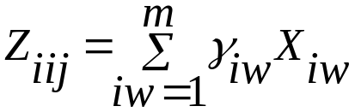
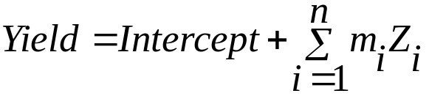

Where ,
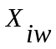 is the value of the weather variable under study Wth week.
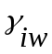 is respective correlation with yield.
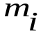 = respective coefficient

5. TECHNOLOGY USED:
We used Spyder as a software and the language
Python(3.7)

6. RESULT:
From previous 27 years data and system output, the performance accuracy is 0.91 for train data. And r2 score for predicted value is -2.01. Our actual yield for year for 1995-96 is 1981 kg/ha and predicted yield is 1783.71 kg/ha.
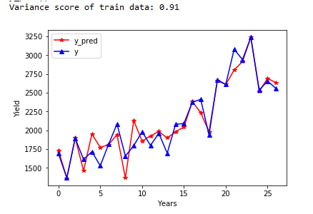
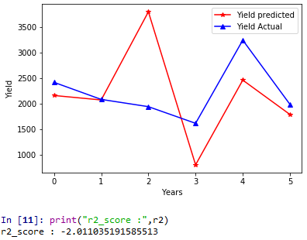

7. FUTURE WORK:
It gives idea about how weather parameters affect the crop, we will be able to predict the performance of a given variety in a given field under a given management practice. We will be able to increase the rate of genetic gain, breed crops to withstand weather variability, and improve access to farmers with evidence-based recommendations.

